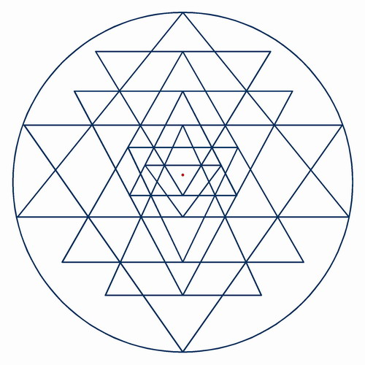
Yin Yoga with Jamie Lee

______________________________________________________________________________
______________________________________________________________________________
______________________________________________________________________________
______________________________________________________________________________
______________________________________________________________________________
______________________________________________________________________________
______________________________________________________________________________
______________________________________________________________________________
______________________________________________________________________________
______________________________________________________________________________
______________________________________________________________________________
______________________________________________________________________________
______________________________________________________________________________
______________________________________________________________________________
______________________________________________________________________________
______________________________________________________________________________
______________________________________________________________________________
______________________________________________________________________________
______________________________________________________________________________
______________________________________________________________________________
______________________________________________________________________________
______________________________________________________________________________
______________________________________________________________________________
______________________________________________________________________________
______________________________________________________________________________
______________________________________________________________________________
______________________________________________________________________________
______________________________________________________________________________
______________________________________________________________________________
______________________________________________________________________________
______________________________________________________________________________
______________________________________________________________________________
______________________________________________________________________________
______________________________________________________________________________
______________________________________________________________________________
______________________________________________________________________________
______________________________________________________________________________
______________________________________________________________________________
______________________________________________________________________________
______________________________________________________________________________
______________________________________________________________________________
Supta Baddha Konasana
Supta = Reclined or Sleeping | Baddha = Bound | Kona = Angle
“Sleeping Bound Angle Position”

Stimulates: abdominal organs like the ovaries, prostate gland, bladder, kidneys, plus the heart and improves general circulation.
Stretches: the inner things, groins, particularily the adductor group
Relieves: symptoms of stress, mild depression, menstruation and menopause.

______________________________________________________________________________
______________________________________________________________________________
______________________________________________________________________________
______________________________________________________________________________
______________________________________________________________________________
______________________________________________________________________________
______________________________________________________________________________
____________________________________________________________________________________________________________________________________________________________
______________________________________________________________________________
______________________________________________________________________________
______________________________________________________________________________
______________________________________________________________________________
______________________________________________________________________________
______________________________________________________________________________
______________________________________________________________________________
______________________________________________________________________________
______________________________________________________________________________
______________________________________________________________________________
______________________________________________________________________________
______________________________________________________________________________
______________________________________________________________________________
______________________________________________________________________________
______________________________________________________________________________
______________________________________________________________________________
______________________________________________________________________________
______________________________________________________________________________
______________________________________________________________________________
______________________________________________________________________________
______________________________________________________________________________
______________________________________________________________________________
______________________________________________________________________________
______________________________________________________________________________
______________________________________________________________________________
______________________________________________________________________________
______________________________________________________________________________
______________________________________________________________________________
______________________________________________________________________________
______________________________________________________________________________
______________________________________________________________________________
______________________________________________________________________________
______________________________________________________________________________
______________________________________________________________________________
______________________________________________________________________________
______________________________________________________________________________
______________________________________________________________________________
______________________________________________________________________________
______________________________________________________________________________
______________________________________________________________________________
______________________________________________________________________________
______________________________________________________________________________
______________________________________________________________________________
______________________________________________________________________________
______________________________________________________________________________
Baddha Konasana
Baddha = Bound | Kona = Angle
“Bound Angle Position”

Stimulates: abdominal organs like the ovaries, prostate gland, bladder, kidneys, plus the heart and improves general circulation.
Stretches: the inner things, groins, particularly the adductor group of adductor longus, brevis and magus.
Relieves: symptoms of stress, mild depression, anxiety, fatigue. Soothes sciatica. Theraputic for flat feet, high blood pressure, infertility, asthma

______________________________________________________________________________
______________________________________________________________________________
______________________________________________________________________________
______________________________________________________________________________
______________________________________________________________________________
______________________________________________________________________________
______________________________________________________________________________
______________________________________________________________________________
______________________________________________________________________________
______________________________________________________________________________
______________________________________________________________________________
______________________________________________________________________________
______________________________________________________________________________
______________________________________________________________________________
______________________________________________________________________________
______________________________________________________________________________
______________________________________________________________________________
______________________________________________________________________________
______________________________________________________________________________
______________________________________________________________________________
______________________________________________________________________________
______________________________________________________________________________
______________________________________________________________________________
______________________________________________________________________________
______________________________________________________________________________
______________________________________________________________________________
______________________________________________________________________________
______________________________________________________________________________
______________________________________________________________________________
______________________________________________________________________________
______________________________________________________________________________
______________________________________________________________________________
______________________________________________________________________________
______________________________________________________________________________
______________________________________________________________________________
______________________________________________________________________________
______________________________________________________________________________
______________________________________________________________________________
______________________________________________________________________________
______________________________________________________________________________
______________________________________________________________________________
______________________________________________________________________________
______________________________________________________________________________
______________________________________________________________________________
______________________________________________________________________________
______________________________________________________________________________
______________________________________________________________________________
______________________________________________________________________________
______________________________________________________________________________
______________________________________________________________________________
______________________________________________________________________________
Balasana (with wide knees)
Bala = child
“childs pose”
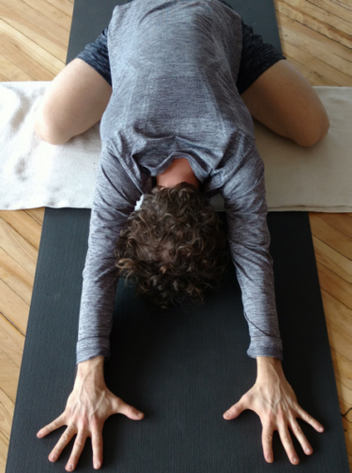
Stimulates: abdominal digestive organs, and kidneys.
Stretches: the inner things, groins, particularly the adductor group of adductor longus, brevis and magus. The outer hip, quadricep and ankle joint.
Relieves: symptoms of stress, fatigue, back and neck pin (with head and torso supported). Soothing to the brain. Aids digestion, relieves cramps – both menstrual & from eating.

______________________________________________________________________________
______________________________________________________________________________
______________________________________________________________________________
______________________________________________________________________________
______________________________________________________________________________
______________________________________________________________________________
______________________________________________________________________________
______________________________________________________________________________
______________________________________________________________________________
______________________________________________________________________________
______________________________________________________________________________
______________________________________________________________________________
______________________________________________________________________________
______________________________________________________________________________
______________________________________________________________________________
______________________________________________________________________________
______________________________________________________________________________
______________________________________________________________________________
______________________________________________________________________________
______________________________________________________________________________
______________________________________________________________________________
______________________________________________________________________________
______________________________________________________________________________
______________________________________________________________________________
______________________________________________________________________________
______________________________________________________________________________
______________________________________________________________________________
______________________________________________________________________________
______________________________________________________________________________
______________________________________________________________________________
______________________________________________________________________________
______________________________________________________________________________
______________________________________________________________________________
______________________________________________________________________________
______________________________________________________________________________
______________________________________________________________________________
______________________________________________________________________________
______________________________________________________________________________
______________________________________________________________________________
______________________________________________________________________________
______________________________________________________________________________
______________________________________________________________________________
______________________________________________________________________________
______________________________________________________________________________
______________________________________________________________________________
______________________________________________________________________________
______________________________________________________________________________
______________________________________________________________________________
______________________________________________________________________________
______________________________________________________________________________
______________________________________________________________________________
______________________________________________________________________________
______________________________________________________________________________
Uttanasana
Uttana = Intense Stretch
“Intense Stretch Pose”
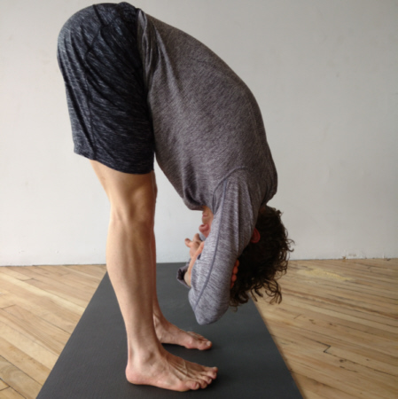

Stimulates: abdominal digestive organs, liver & kidney. Warms the quaricep. Compresses stomach and internal organs providing a compression massage.
Stretches: the lower spine, hamstrings, calf muscles
Relieves: symptoms of stress, fatigue, lower back pain. Slows heart rate, relieves menstrual cramps.

______________________________________________________________________________
______________________________________________________________________________
______________________________________________________________________________
______________________________________________________________________________
______________________________________________________________________________
______________________________________________________________________________
______________________________________________________________________________
______________________________________________________________________________
______________________________________________________________________________
______________________________________________________________________________
______________________________________________________________________________
______________________________________________________________________________
______________________________________________________________________________
______________________________________________________________________________
______________________________________________________________________________
______________________________________________________________________________
______________________________________________________________________________
______________________________________________________________________________
______________________________________________________________________________
______________________________________________________________________________
______________________________________________________________________________
______________________________________________________________________________
______________________________________________________________________________
______________________________________________________________________________
______________________________________________________________________________
______________________________________________________________________________
______________________________________________________________________________
______________________________________________________________________________
______________________________________________________________________________
______________________________________________________________________________
______________________________________________________________________________
______________________________________________________________________________
______________________________________________________________________________
______________________________________________________________________________
______________________________________________________________________________
______________________________________________________________________________
______________________________________________________________________________
______________________________________________________________________________
______________________________________________________________________________
______________________________________________________________________________
______________________________________________________________________________
______________________________________________________________________________
______________________________________________________________________________
______________________________________________________________________________
______________________________________________________________________________
______________________________________________________________________________
______________________________________________________________________________
______________________________________________________________________________
______________________________________________________________________________
______________________________________________________________________________
______________________________________________________________________________
______________________________________________________________________________
______________________________________________________________________________
Paschimottanasana
Paschimo = Western | Uttana = Intense Stretch
“Western Intense Stretch Posture”
Stimulates: Liver, kidney, ovaries & uterus. Improves digestion by compressing the stomach organ and massages the heart.
Stretches: the lower spine, hamstrings, calf muscles, nerves along the spine
Relieves: Soothes headaches, anxiety, fatigue. Theraputic for high blood pressure & insomnia.

______________________________________________________________________________
______________________________________________________________________________
______________________________________________________________________________
______________________________________________________________________________
______________________________________________________________________________
______________________________________________________________________________
______________________________________________________________________________
______________________________________________________________________________
______________________________________________________________________________
______________________________________________________________________________
______________________________________________________________________________
______________________________________________________________________________
______________________________________________________________________________
______________________________________________________________________________
______________________________________________________________________________
______________________________________________________________________________
______________________________________________________________________________
______________________________________________________________________________
______________________________________________________________________________
______________________________________________________________________________
______________________________________________________________________________
______________________________________________________________________________
______________________________________________________________________________
______________________________________________________________________________
______________________________________________________________________________
______________________________________________________________________________
______________________________________________________________________________
______________________________________________________________________________
______________________________________________________________________________
______________________________________________________________________________
______________________________________________________________________________
______________________________________________________________________________
______________________________________________________________________________
______________________________________________________________________________
______________________________________________________________________________
______________________________________________________________________________
______________________________________________________________________________
______________________________________________________________________________
______________________________________________________________________________
______________________________________________________________________________
______________________________________________________________________________
______________________________________________________________________________
______________________________________________________________________________
______________________________________________________________________________
______________________________________________________________________________
______________________________________________________________________________
______________________________________________________________________________
______________________________________________________________________________
______________________________________________________________________________
______________________________________________________________________________
______________________________________________________________________________
______________________________________________________________________________
______________________________________________________________________________
______________________________________________________________________________
______________________________________________________________________________
______________________________________________________________________________
______________________________________________________________________________
Janu Sirsasana A
Janu = Knee | Sirsa = Head
“Head to Knee Posture”
Stimulates: Liver, kidney, bladder. Improves digestion by compressing the stomach.
Stretches: the lower spine, hamstrings, calf muscles, nerves along the spine
Relieves: Soothes headaches, anxiety, fatigue. Theraputic for high blood pressure & insomnia.

______________________________________________________________________________
______________________________________________________________________________
______________________________________________________________________________
______________________________________________________________________________
______________________________________________________________________________
______________________________________________________________________________
______________________________________________________________________________
______________________________________________________________________________
______________________________________________________________________________
______________________________________________________________________________
______________________________________________________________________________
______________________________________________________________________________
______________________________________________________________________________
______________________________________________________________________________
______________________________________________________________________________
______________________________________________________________________________
______________________________________________________________________________
______________________________________________________________________________
______________________________________________________________________________
______________________________________________________________________________
______________________________________________________________________________
______________________________________________________________________________
______________________________________________________________________________
______________________________________________________________________________
______________________________________________________________________________
______________________________________________________________________________
______________________________________________________________________________
______________________________________________________________________________
______________________________________________________________________________
______________________________________________________________________________
______________________________________________________________________________
______________________________________________________________________________
______________________________________________________________________________
______________________________________________________________________________
______________________________________________________________________________
______________________________________________________________________________
______________________________________________________________________________
______________________________________________________________________________
______________________________________________________________________________
______________________________________________________________________________
______________________________________________________________________________
______________________________________________________________________________
______________________________________________________________________________
______________________________________________________________________________
______________________________________________________________________________
______________________________________________________________________________
______________________________________________________________________________
______________________________________________________________________________
______________________________________________________________________________
______________________________________________________________________________
______________________________________________________________________________
______________________________________________________________________________
______________________________________________________________________________
______________________________________________________________________________
______________________________________________________________________________
______________________________________________________________________________
______________________________________________________________________________
Upavishta Konasana
Upavishta = Seated | Kona = Angle
Stimulates: Liver, kidney, ovaries and abdominal organs.
Stretches: groins, lower spine, hip, hamstrings, calf muscles, nerves along the spine
Relieves: Soothes headaches, anxiety, fatigue. Calms the brain.

____________________________________________________________________________________________________________________________________________________________________________________________________________________________________________________________________________________________________________________________________________________________________________________________________________________________________________________________________________________________________________________________________________________________________________________________________________________________________________________________________________________________________________________________________________________________________________________________________________________________________________________________________________________________________________________________________________________________________________________________________________________________________________________________________________________________________________________________________________________________________________________________________________________________________________________________________________________________________________________________________________________________________________________________________________________________________________________________________________________________________________________________________________________________________________________________________________________________________________________________________________________________________________________________________________________________________________________________________________________________________________________________________________________________________________________________________________________________________________________________________________________________________________________________________________________________________________
______________________________________________________________________________
______________________________________________________________________________
______________________________________________________________________________
______________________________________________________________________________
______________________________________________________________________________
______________________________________________________________________________
______________________________________________________________________________
______________________________________________________________________________
______________________________________________________________________________
______________________________________________________________________________
______________________________________________________________________________
______________________________________________________________________________
______________________________________________________________________________
______________________________________________________________________________
______________________________________________________________________________
______________________________________________________________________________
______________________________________________________________________________
______________________________________________________________________________
______________________________________________________________________________
______________________________________________________________________________
______________________________________________________________________________
______________________________________________________________________________
______________________________________________________________________________
______________________________________________________________________________
______________________________________________________________________________
______________________________________________________________________________
______________________________________________________________________________
______________________________________________________________________________
______________________________________________________________________________
______________________________________________________________________________
______________________________________________________________________________
______________________________________________________________________________
______________________________________________________________________________
______________________________________________________________________________
______________________________________________________________________________
Supta Padangusthasana
Supta = Sleeping | Pada = Foot | Angustha = Big Toe
“Sleeping Big Toe Posture”
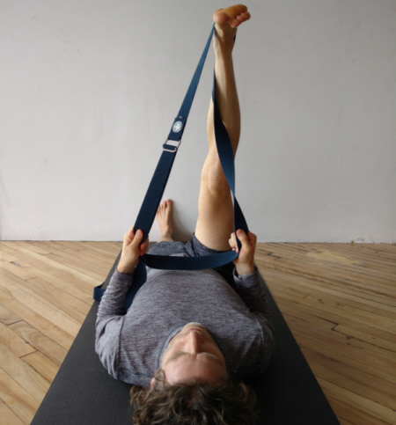
Stimulates: Prostate and abdominal organs.
Stretches: groins, hamstrings, hip flexor
Relieves: Improves digestion, relieves back ache, sciatica & menstrual discomfort. Theraputic for high blood pressure, flat feet and infertility.

______________________________________________________________________________
______________________________________________________________________________
______________________________________________________________________________
______________________________________________________________________________
______________________________________________________________________________
______________________________________________________________________________
______________________________________________________________________________
______________________________________________________________________________
______________________________________________________________________________
______________________________________________________________________________
______________________________________________________________________________
______________________________________________________________________________
______________________________________________________________________________
______________________________________________________________________________
______________________________________________________________________________

_____________________________________________________________________________________
_____________________________________________________________________________________
_____________________________________________________________________________________
_____________________________________________________________________________________
_____________________________________________________________________________________
_____________________________________________________________________________________
_____________________________________________________________________________________
_____________________________________________________________________________________
_____________________________________________________________________________________
_____________________________________________________________________________________
_____________________________________________________________________________________
_____________________________________________________________________________________
_____________________________________________________________________________________
_____________________________________________________________________________________
_____________________________________________________________________________________
_____________________________________________________________________________________
_____________________________________________________________________________________
_____________________________________________________________________________________
_____________________________________________________________________________________
_____________________________________________________________________________________
_____________________________________________________________________________________
_____________________________________________________________________________________
_____________________________________________________________________________________
_____________________________________________________________________________________
_____________________________________________________________________________________
_____________________________________________________________________________________
_____________________________________________________________________________________
_____________________________________________________________________________________
_____________________________________________________________________________________
_____________________________________________________________________________________
Eka Pada Rajakapotasana

eka = one | pada = leg or foot | raja = king | kapota = pigeon | asana = pose
One-Legged King Pigeon Pose, forward bend variation

“Sleeping Pigeon Pose”
Stimulates: abdominal organs, kidney
Stretches: groins, gluts, all outer hips muscles, hip flexor
Relieves: Piriformis, sciatic pain, lower back pain, helps with urinary track disorders. Calming to the brain when a block is used. Reduces stress and tension by helping to create a state of introspection.

______________________________________________________________________________
______________________________________________________________________________
______________________________________________________________________________
______________________________________________________________________________
______________________________________________________________________________
______________________________________________________________________________
______________________________________________________________________________
______________________________________________________________________________
______________________________________________________________________________
______________________________________________________________________________
______________________________________________________________________________
Variations:
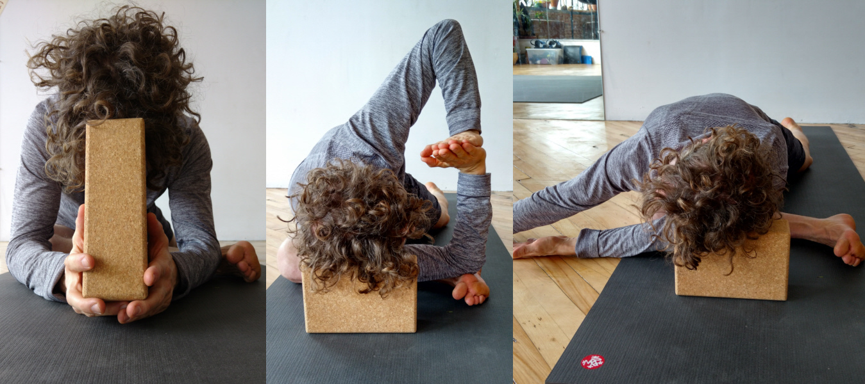

______________________________________________________________________________
______________________________________________________________________________
______________________________________________________________________________
______________________________________________________________________________
______________________________________________________________________________
______________________________________________________________________________
______________________________________________________________________________
______________________________________________________________________________
______________________________________________________________________________
______________________________________________________________________________
______________________________________________________________________________
______________________________________________________________________________
______________________________________________________________________________
______________________________________________________________________________
______________________________________________________________________________
______________________________________________________________________________
______________________________________________________________________________
______________________________________________________________________________
______________________________________________________________________________
______________________________________________________________________________
______________________________________________________________________________
______________________________________________________________________________
______________________________________________________________________________
______________________________________________________________________________
______________________________________________________________________________
Anjaneyasana
Anjani = Hanumans mother

Stimulates: stomach, spleen, liver, gall bladder, kidneys, urinary track
Stretches: groins, gluts, all outer hips muscles, deep inner hip, quadriceps, hip flexor
Relieves: Piriformis, sciatic pain, lower back pain.

______________________________________________________________________________
______________________________________________________________________________
______________________________________________________________________________
______________________________________________________________________________
______________________________________________________________________________
______________________________________________________________________________
______________________________________________________________________________
______________________________________________________________________________
______________________________________________________________________________
______________________________________________________________________________
______________________________________________________________________________
______________________________________________________________________________
______________________________________________________________________________
______________________________________________________________________________
______________________________________________________________________________
______________________________________________________________________________
______________________________________________________________________________
______________________________________________________________________________
______________________________________________________________________________
______________________________________________________________________________
______________________________________________________________________________
______________________________________________________________________________
______________________________________________________________________________
______________________________________________________________________________
______________________________________________________________________________
______________________________________________________________________________
______________________________________________________________________________
______________________________________________________________________________
______________________________________________________________________________
______________________________________________________________________________
______________________________________________________________________________
______________________________________________________________________________
______________________________________________________________________________
______________________________________________________________________________
______________________________________________________________________________
______________________________________________________________________________
______________________________________________________________________________
______________________________________________________________________________
______________________________________________________________________________
______________________________________________________________________________
______________________________________________________________________________
______________________________________________________________________________
______________________________________________________________________________
______________________________________________________________________________
______________________________________________________________________________
______________________________________________________________________________
______________________________________________________________________________
______________________________________________________________________________
______________________________________________________________________________
______________________________________________________________________________
______________________________________________________________________________
______________________________________________________________________________
______________________________________________________________________________
______________________________________________________________________________
______________________________________________________________________________
______________________________________________________________________________
______________________________________________________________________________
______________________________________________________________________________
______________________________________________________________________________
______________________________________________________________________________
______________________________________________________________________________
Ardha Baddha Padma Paschimottanasana
ardhabaddha = half bound | padma = lotus | paschi = western facing | uttana = intense stretch
“Half Bound Lotus Western Intense Stretch Posture”
Stimulates: the digestive and excretory systems
Stretches: groins, gluts, all outer hips muscles, external rotators
Relieves: helps to reduce excess fat in the body, insomnia and asthma

______________________________________________________________________________
______________________________________________________________________________
______________________________________________________________________________
______________________________________________________________________________
______________________________________________________________________________
______________________________________________________________________________
______________________________________________________________________________
______________________________________________________________________________
______________________________________________________________________________
______________________________________________________________________________
______________________________________________________________________________
______________________________________________________________________________
______________________________________________________________________________
______________________________________________________________________________
Variations:

_____________________________________________________________________________________
_____________________________________________________________________________________
_____________________________________________________________________________________
_____________________________________________________________________________________
_____________________________________________________________________________________
_____________________________________________________________________________________
_____________________________________________________________________________________
_____________________________________________________________________________________
_____________________________________________________________________________________
_____________________________________________________________________________________
_____________________________________________________________________________________
_____________________________________________________________________________________
_____________________________________________________________________________________
_____________________________________________________________________________________
_____________________________________________________________________________________
_____________________________________________________________________________________
_____________________________________________________________________________________
_____________________________________________________________________________________
_____________________________________________________________________________________
_____________________________________________________________________________________
_____________________________________________________________________________________
_____________________________________________________________________________________
_____________________________________________________________________________________
_____________________________________________________________________________________
_____________________________________________________________________________________
_____________________________________________________________________________________
Baddha Padmasana
Baddha = bound | Padma = lotus
“Bound Lotus Position”
Stimulates: liver, kidney, bladder
Stretches: groins, gluts, all outer hips muscles, external rotators
Relieves: relieves pain on the lower back, knees and ankles. It helps those suffering from insomnia and asthma in the upright position.
______________________________________________________________________________________________________________________________________________________________________________________________________________________________________________________________________________________________________________________________________________________________________________________________________
________________________________________________________________________________________________________________________________________________________________________________________________________________________________________________________________________________________________________________________________________________________________________________________________________________________________________________________________________________________________________________________________________________________________________________________________________________________________________________
Variations:
______________________________________________________________________________
______________________________________________________________________________
______________________________________________________________________________
______________________________________________________________________________
______________________________________________________________________________
______________________________________________________________________________
______________________________________________________________________________
______________________________________________________________________________
______________________________________________________________________________
______________________________________________________________________________
______________________________________________________________________________
______________________________________________________________________________
______________________________________________________________________________
______________________________________________________________________________
______________________________________________________________________________
______________________________________________________________________________
______________________________________________________________________________
______________________________________________________________________________
______________________________________________________________________________
______________________________________________________________________________
Bharadvajasana
Bharadvaja = a sage or rishi
“The Asana dedicated to the rishi Bharadvaja”
Stimulates: liver, kidney, bladder, digestion
Stretches: groins, gluts, all outer hips muscles, both internal & external rotators
Relieves: gas, improves digestion, symptoms of menopause, swelling in the legs, along with being therapeutic for high blood pressure and asthma

______________________________________________________________________________
______________________________________________________________________________
______________________________________________________________________________
______________________________________________________________________________
______________________________________________________________________________
______________________________________________________________________________
______________________________________________________________________________
______________________________________________________________________________
______________________________________________________________________________
______________________________________________________________________________
______________________________________________________________________________
______________________________________________________________________________
______________________________________________________________________________
______________________________________________________________________________
______________________________________________________________________________
______________________________________________________________________________
______________________________________________________________________________
______________________________________________________________________________
______________________________________________________________________________
______________________________________________________________________________
______________________________________________________________________________
______________________________________________________________________________
______________________________________________________________________________
______________________________________________________________________________
______________________________________________________________________________
______________________________________________________________________________
______________________________________________________________________________
______________________________________________________________________________
______________________________________________________________________________
______________________________________________________________________________
______________________________________________________________________________
______________________________________________________________________________
______________________________________________________________________________
______________________________________________________________________________
______________________________________________________________________________
______________________________________________________________________________
______________________________________________________________________________
______________________________________________________________________________
______________________________________________________________________________
______________________________________________________________________________
______________________________________________________________________________
______________________________________________________________________________
______________________________________________________________________________
______________________________________________________________________________
______________________________________________________________________________
______________________________________________________________________________
______________________________________________________________________________
______________________________________________________________________________
______________________________________________________________________________
______________________________________________________________________________
______________________________________________________________________________
Ardha Matsyendrasana
Ardha = half | matsya = fish | indra = king
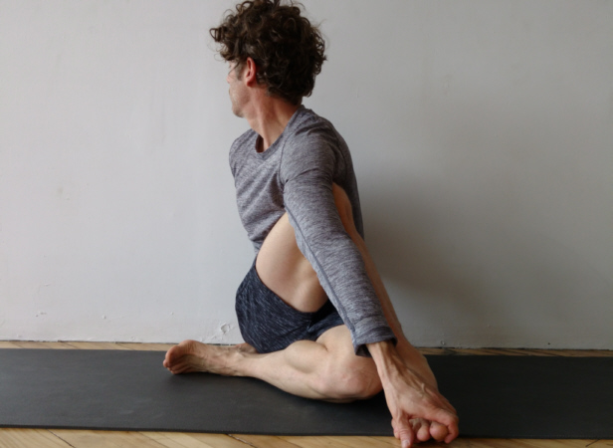
Stimulates: tones the abdominal organs, improves digestion,
Stretches: gluts, all outer hips muscles, external rotators, spinal muscles
Relieves: back pain, menstrual pain, urinary tract infections.
Calming to the mind, strengthening the nervous system and alleviating stress.

______________________________________________________________________________
______________________________________________________________________________
______________________________________________________________________________
______________________________________________________________________________
______________________________________________________________________________
______________________________________________________________________________
______________________________________________________________________________
______________________________________________________________________________
______________________________________________________________________________
______________________________________________________________________________
______________________________________________________________________________
______________________________________________________________________________
______________________________________________________________________________
______________________________________________________________________________
______________________________________________________________________________
______________________________________________________________________________
______________________________________________________________________________
______________________________________________________________________________
______________________________________________________________________________
______________________________________________________________________________
______________________________________________________________________________
______________________________________________________________________________
______________________________________________________________________________
______________________________________________________________________________
______________________________________________________________________________
______________________________________________________________________________
______________________________________________________________________________
______________________________________________________________________________
______________________________________________________________________________
______________________________________________________________________________
______________________________________________________________________________
______________________________________________________________________________
______________________________________________________________________________
______________________________________________________________________________
______________________________________________________________________________
______________________________________________________________________________
______________________________________________________________________________
______________________________________________________________________________
______________________________________________________________________________
______________________________________________________________________________
______________________________________________________________________________
______________________________________________________________________________
______________________________________________________________________________
______________________________________________________________________________
______________________________________________________________________________
______________________________________________________________________________
______________________________________________________________________________
______________________________________________________________________________
______________________________________________________________________________
______________________________________________________________________________
______________________________________________________________________________
______________________________________________________________________________
______________________________________________________________________________
______________________________________________________________________________
______________________________________________________________________________
______________________________________________________________________________
______________________________________________________________________________
______________________________________________________________________________
______________________________________________________________________________
Heart Chest Opener
Stimulates: sympathetic nervous system, blood pressure
Stretches: the spine, the chest, ribs, throat, lungs
Relieves: tension throughout the spine and neck.

______________________________________________________________________________
______________________________________________________________________________
______________________________________________________________________________
______________________________________________________________________________
______________________________________________________________________________
______________________________________________________________________________
______________________________________________________________________________
______________________________________________________________________________
______________________________________________________________________________
______________________________________________________________________________
______________________________________________________________________________
______________________________________________________________________________
______________________________________________________________________________
______________________________________________________________________________
______________________________________________________________________________
______________________________________________________________________________
______________________________________________________________________________
______________________________________________________________________________
______________________________________________________________________________
______________________________________________________________________________
______________________________________________________________________________
______________________________________________________________________________
______________________________________________________________________________
______________________________________________________________________________
______________________________________________________________________________
______________________________________________________________________________
______________________________________________________________________________
______________________________________________________________________________
______________________________________________________________________________
______________________________________________________________________________
______________________________________________________________________________
______________________________________________________________________________
______________________________________________________________________________
______________________________________________________________________________
______________________________________________________________________________
______________________________________________________________________________
______________________________________________________________________________
______________________________________________________________________________
______________________________________________________________________________
______________________________________________________________________________
______________________________________________________________________________
______________________________________________________________________________
______________________________________________________________________________
______________________________________________________________________________
______________________________________________________________________________
______________________________________________________________________________
______________________________________________________________________________
______________________________________________________________________________
______________________________________________________________________________
______________________________________________________________________________
______________________________________________________________________________
______________________________________________________________________________
______________________________________________________________________________
______________________________________________________________________________
______________________________________________________________________________
______________________________________________________________________________
______________________________________________________________________________
______________________________________________________________________________
______________________________________________________________________________
______________________________________________________________________________
______________________________________________________________________________
______________________________________________________________________________
______________________________________________________________________________
______________________________________________________________________________
______________________________________________________________________________
______________________________________________________________________________
Salamba Setu Bandhasana
Salamba = Supported | Setu = Bridge | Bandha
“Supported Bridge Pose”
Stimulates: abdominal organs, lungs, thyroid, digestion
Stretches: the abdomen, lumbar & thoracic spine, chest, shoulders
Relieves: helps to drain fluid from legs, quiets the mind, promotes introspection, stress relieving. Reduces anxiety, fatigue, backache, headaches, insomnia. Helps with menopause, menstral cramps. Theraputic for asthma, high blood pressure, osteoporosis & sinusitis

______________________________________________________________________________
______________________________________________________________________________
______________________________________________________________________________
______________________________________________________________________________
______________________________________________________________________________
______________________________________________________________________________
______________________________________________________________________________
______________________________________________________________________________
______________________________________________________________________________
______________________________________________________________________________
______________________________________________________________________________
______________________________________________________________________________
______________________________________________________________________________
______________________________________________________________________________
______________________________________________________________________________
______________________________________________________________________________
______________________________________________________________________________
______________________________________________________________________________
______________________________________________________________________________
______________________________________________________________________________
______________________________________________________________________________
______________________________________________________________________________
______________________________________________________________________________
______________________________________________________________________________
______________________________________________________________________________
______________________________________________________________________________
______________________________________________________________________________
______________________________________________________________________________
______________________________________________________________________________
______________________________________________________________________________
______________________________________________________________________________
______________________________________________________________________________
______________________________________________________________________________
______________________________________________________________________________
______________________________________________________________________________
______________________________________________________________________________
______________________________________________________________________________
______________________________________________________________________________
______________________________________________________________________________
______________________________________________________________________________
______________________________________________________________________________
______________________________________________________________________________
______________________________________________________________________________
______________________________________________________________________________
______________________________________________________________________________
______________________________________________________________________________
______________________________________________________________________________
______________________________________________________________________________
______________________________________________________________________________
______________________________________________________________________________
______________________________________________________________________________
______________________________________________________________________________
______________________________________________________________________________
______________________________________________________________________________
______________________________________________________________________________
______________________________________________________________________________
______________________________________________________________________________
Virasana
Vira = Hero
“Hero’s Pose”
Stimulates: digestion, blood circulation
Stretches: feet, ankles, front or lower & upper leg
Relieves: constipation, stomach disorders, calming to the mind

______________________________________________________________________________
______________________________________________________________________________
______________________________________________________________________________
______________________________________________________________________________
______________________________________________________________________________
______________________________________________________________________________
______________________________________________________________________________
______________________________________________________________________________
______________________________________________________________________________
______________________________________________________________________________
______________________________________________________________________________
______________________________________________________________________________
______________________________________________________________________________
______________________________________________________________________________
______________________________________________________________________________
______________________________________________________________________________
______________________________________________________________________________
______________________________________________________________________________
______________________________________________________________________________
______________________________________________________________________________
______________________________________________________________________________
______________________________________________________________________________
______________________________________________________________________________
______________________________________________________________________________
______________________________________________________________________________
______________________________________________________________________________
______________________________________________________________________________
______________________________________________________________________________
______________________________________________________________________________
______________________________________________________________________________
______________________________________________________________________________
______________________________________________________________________________
______________________________________________________________________________
______________________________________________________________________________
______________________________________________________________________________
______________________________________________________________________________
______________________________________________________________________________
______________________________________________________________________________
______________________________________________________________________________
______________________________________________________________________________
______________________________________________________________________________
______________________________________________________________________________
______________________________________________________________________________
______________________________________________________________________________
______________________________________________________________________________
______________________________________________________________________________
______________________________________________________________________________
______________________________________________________________________________
______________________________________________________________________________
______________________________________________________________________________
______________________________________________________________________________
______________________________________________________________________________
______________________________________________________________________________
______________________________________________________________________________
______________________________________________________________________________
______________________________________________________________________________
______________________________________________________________________________
______________________________________________________________________________
______________________________________________________________________________
______________________________________________________________________________
______________________________________________________________________________
______________________________________________________________________________
Supta Virasana
Supta = Sleeping | Vira = Hero
“Sleeping Hero’s Pose”
Stimulates: digestion, stomach, spleen, blood circulation, stimulates thyroid when head back
Stretches: feet, ankles, front or lower & upper leg, abdomen, hip flexor, sacral-lumbar
Relieves: tired legs. Therapeutic for: arthritis, asthma, diarrhea, digestive problems, flat feet, head cold, headache, high blood pressure, infertility, insomnia, intestinal gas and acidity, menstrual discomfort, respiratory ailments, sciatica, varicose veins.

______________________________________________________________________________
______________________________________________________________________________
______________________________________________________________________________
______________________________________________________________________________
______________________________________________________________________________
______________________________________________________________________________
______________________________________________________________________________
______________________________________________________________________________
______________________________________________________________________________
______________________________________________________________________________
______________________________________________________________________________
______________________________________________________________________________
______________________________________________________________________________
______________________________________________________________________________
______________________________________________________________________________
______________________________________________________________________________
______________________________________________________________________________
______________________________________________________________________________
______________________________________________________________________________
______________________________________________________________________________
______________________________________________________________________________
______________________________________________________________________________
______________________________________________________________________________
______________________________________________________________________________
______________________________________________________________________________
______________________________________________________________________________
______________________________________________________________________________
______________________________________________________________________________
______________________________________________________________________________
______________________________________________________________________________
______________________________________________________________________________
______________________________________________________________________________
______________________________________________________________________________
______________________________________________________________________________
______________________________________________________________________________
______________________________________________________________________________
______________________________________________________________________________
______________________________________________________________________________
______________________________________________________________________________
______________________________________________________________________________
______________________________________________________________________________
______________________________________________________________________________
______________________________________________________________________________
______________________________________________________________________________
______________________________________________________________________________
______________________________________________________________________________
______________________________________________________________________________
______________________________________________________________________________
______________________________________________________________________________
______________________________________________________________________________
______________________________________________________________________________
______________________________________________________________________________
______________________________________________________________________________
______________________________________________________________________________
______________________________________________________________________________
______________________________________________________________________________
______________________________________________________________________________
______________________________________________________________________________
______________________________________________________________________________
Ustrasana
Ustra = Camel
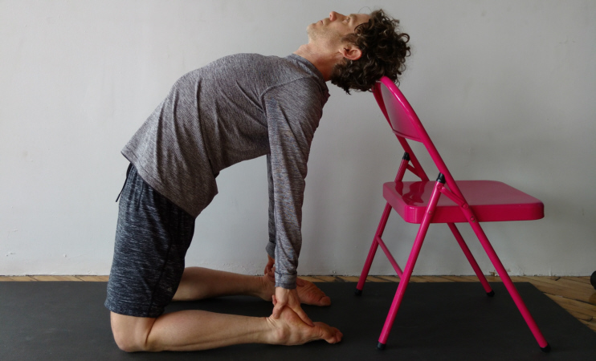
Stimulates: digestion & elimination, stimulates thyroid when head back, nervous system
Stretches: ankles, front or lower & upper leg, abdomen, hip flexor, sacral-lumbar
Relieves: lower back pain, strengthens chest and shoulders, loosens vertebrae, rejuvenate or increases energy levels. Releases anxiety and stress. Allows deep rooted emotions to rise to the surface.

______________________________________________________________________________
______________________________________________________________________________
______________________________________________________________________________
______________________________________________________________________________
______________________________________________________________________________
______________________________________________________________________________
______________________________________________________________________________
______________________________________________________________________________
______________________________________________________________________________
______________________________________________________________________________
______________________________________________________________________________
______________________________________________________________________________
______________________________________________________________________________
______________________________________________________________________________
______________________________________________________________________________
______________________________________________________________________________
______________________________________________________________________________
______________________________________________________________________________
______________________________________________________________________________
______________________________________________________________________________
______________________________________________________________________________
______________________________________________________________________________
______________________________________________________________________________
______________________________________________________________________________
______________________________________________________________________________
______________________________________________________________________________
______________________________________________________________________________
______________________________________________________________________________
______________________________________________________________________________
______________________________________________________________________________
______________________________________________________________________________
______________________________________________________________________________
______________________________________________________________________________
______________________________________________________________________________
______________________________________________________________________________
______________________________________________________________________________
______________________________________________________________________________
______________________________________________________________________________
______________________________________________________________________________
______________________________________________________________________________
______________________________________________________________________________
______________________________________________________________________________
______________________________________________________________________________
______________________________________________________________________________
______________________________________________________________________________
______________________________________________________________________________
______________________________________________________________________________
______________________________________________________________________________
______________________________________________________________________________
______________________________________________________________________________
______________________________________________________________________________
______________________________________________________________________________
______________________________________________________________________________
______________________________________________________________________________
______________________________________________________________________________
______________________________________________________________________________
______________________________________________________________________________
______________________________________________________________________________
______________________________________________________________________________
______________________________________________________________________________

Vipirani Karani
“Legs Up The Wall Pose”
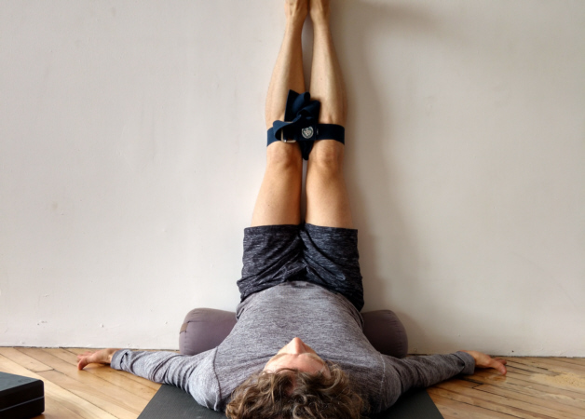
Stimulates: digestion, blood circulation
Stretches: feet, ankles, front or lower & upper leg, abdomen,
Relieves: anxiety, arthritis, digestive problems, headaches, migranes, high & low blood pressure, insomnia, depression, respiratory ailments, urinary disorders, varicose viens, menstral cramps, menopause, tired & cramped legs.
Avoid: glaucoma, retinal problems, heart conditiond, neck & back injuries, respiratory or sinus infections, indigestion, menstration, 2nd & 3rd trimester

______________________________________________________________________________
______________________________________________________________________________
______________________________________________________________________________
______________________________________________________________________________
______________________________________________________________________________
______________________________________________________________________________
______________________________________________________________________________
______________________________________________________________________________
______________________________________________________________________________
______________________________________________________________________________
______________________________________________________________________________
______________________________________________________________________________
______________________________________________________________________________
______________________________________________________________________________
______________________________________________________________________________
______________________________________________________________________________
______________________________________________________________________________
______________________________________________________________________________
______________________________________________________________________________
______________________________________________________________________________
______________________________________________________________________________
______________________________________________________________________________
______________________________________________________________________________
______________________________________________________________________________
______________________________________________________________________________
______________________________________________________________________________
______________________________________________________________________________
______________________________________________________________________________
______________________________________________________________________________
______________________________________________________________________________
______________________________________________________________________________
______________________________________________________________________________
______________________________________________________________________________
______________________________________________________________________________
______________________________________________________________________________
______________________________________________________________________________
______________________________________________________________________________
______________________________________________________________________________
______________________________________________________________________________
______________________________________________________________________________
______________________________________________________________________________
______________________________________________________________________________
______________________________________________________________________________
______________________________________________________________________________
______________________________________________________________________________
______________________________________________________________________________
______________________________________________________________________________
______________________________________________________________________________
______________________________________________________________________________
______________________________________________________________________________
______________________________________________________________________________
______________________________________________________________________________
______________________________________________________________________________
______________________________________________________________________________
Shavasana
Shava = dead body
“Dead body Pose”
Stimulates: introspection, parasympathetic nervous system.
Stretches:
Relieves: Calms the brain, helps relieve stress & mild depression. Relaxes the nervous system, helps with headaches, fatigue, insomnia

______________________________________________________________________________
______________________________________________________________________________
______________________________________________________________________________
______________________________________________________________________________
______________________________________________________________________________
______________________________________________________________________________
______________________________________________________________________________
______________________________________________________________________________
______________________________________________________________________________
______________________________________________________________________________
______________________________________________________________________________
______________________________________________________________________________
______________________________________________________________________________
______________________________________________________________________________
______________________________________________________________________________
______________________________________________________________________________
______________________________________________________________________________
______________________________________________________________________________
______________________________________________________________________________
______________________________________________________________________________
______________________________________________________________________________
______________________________________________________________________________
______________________________________________________________________________
______________________________________________________________________________
______________________________________________________________________________
______________________________________________________________________________
______________________________________________________________________________
______________________________________________________________________________
______________________________________________________________________________
______________________________________________________________________________
______________________________________________________________________________
______________________________________________________________________________
______________________________________________________________________________
______________________________________________________________________________
______________________________________________________________________________
______________________________________________________________________________
______________________________________________________________________________
______________________________________________________________________________
______________________________________________________________________________
______________________________________________________________________________
______________________________________________________________________________
______________________________________________________________________________
______________________________________________________________________________
______________________________________________________________________________
______________________________________________________________________________
______________________________________________________________________________
______________________________________________________________________________
______________________________________________________________________________
______________________________________________________________________________
______________________________________________________________________________
______________________________________________________________________________
______________________________________________________________________________
______________________________________________________________________________
______________________________________________________________________________
______________________________________________________________________________
______________________________________________________________________________
______________________________________________________________________________
______________________________________________________________________________
______________________________________________________________________________
______________________________________________________________________________
______________________________________________________________________________

